Theological Research Seminar 2009-2010
McMaster Divinity College
Hurlburt Hall

Andrew Gabriel

Title: “The Holy Spirit and the Question of Divine Suffering”

Trinitarian doctrines of the divine attributes consistently ignore the implications of pneumatology for the classical doctrine of impassibility (“God does not suffer”) and instead focus on the implications that the passion of Christ has for the suffering of God. Pneumatology confirms for trinitarian theology what has frequently been argued christologically, namely, that God suffers. The biblical texts attribute grief to the Holy Spirit. Further, the notion of the Holy Spirit groaning through and with the prayers of believers as well as the biblical metaphor of ‘rebirth’ further support the conclusion that the Spirit is passible. Lastly, though the Spirit is distinct from creation, the Spirit is indeed immanent to creation and actively enters into the suffering of creation, suffering with creation’s suffering. Overall, these pneumatological perspectives present God as suffering within and along side of that which God has created.

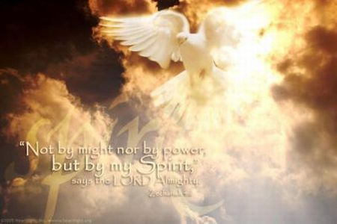


Bio: Andrew Gabriel recently completed his Ph.D. at McMaster Divinity College. He serves as an adjunct professor with Emmanuel Bible College and Tyndale Seminary. In addition, he serves as the Assistant Pastor at Peoples Church in Hamilton, Ontario. He and his wife, Krista, have two darling daughters.

Tuesday, February 9 12:30-1:20 PM

